Install Python 3.6.3

Libraries to install: -

open cmd

type in cmd the following: -

1.) pip3 install tensorflow==1.15

2.) pip3 install matplotlib

3.) pip3 install scipy

4.) pip3 install numpy==1.16.4

5.) pip3 install scikit-learn

6.) pip3 install pandas

7.) pip3 install TensorBoard

How to run the project.

To run the program, we go to the tensorflow folder, open the nntf.py file with IDLE and press f5 to run the module.

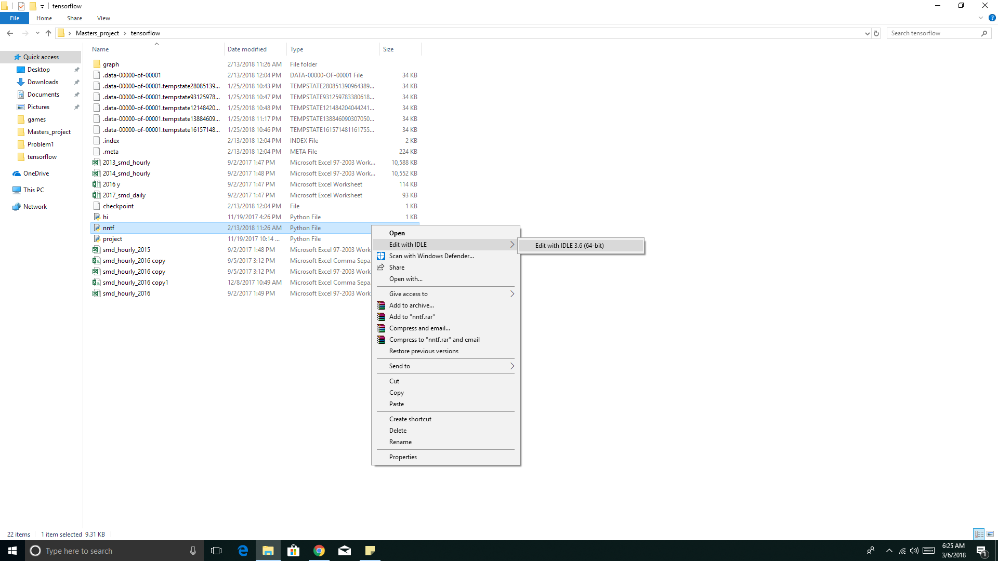

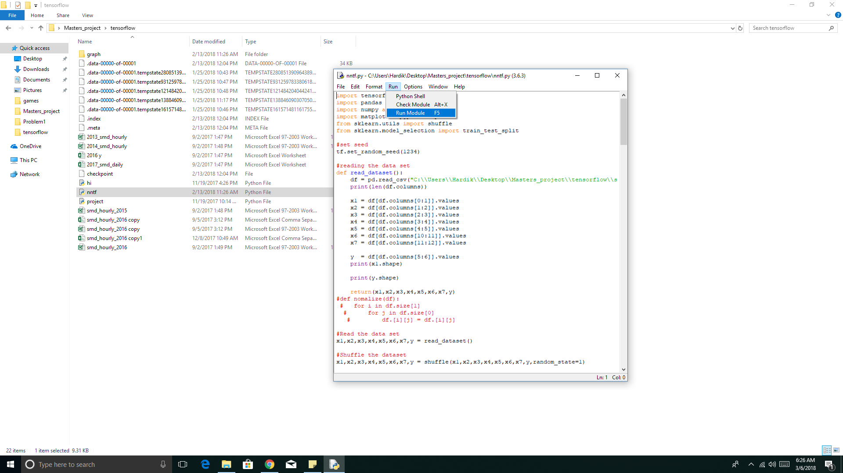

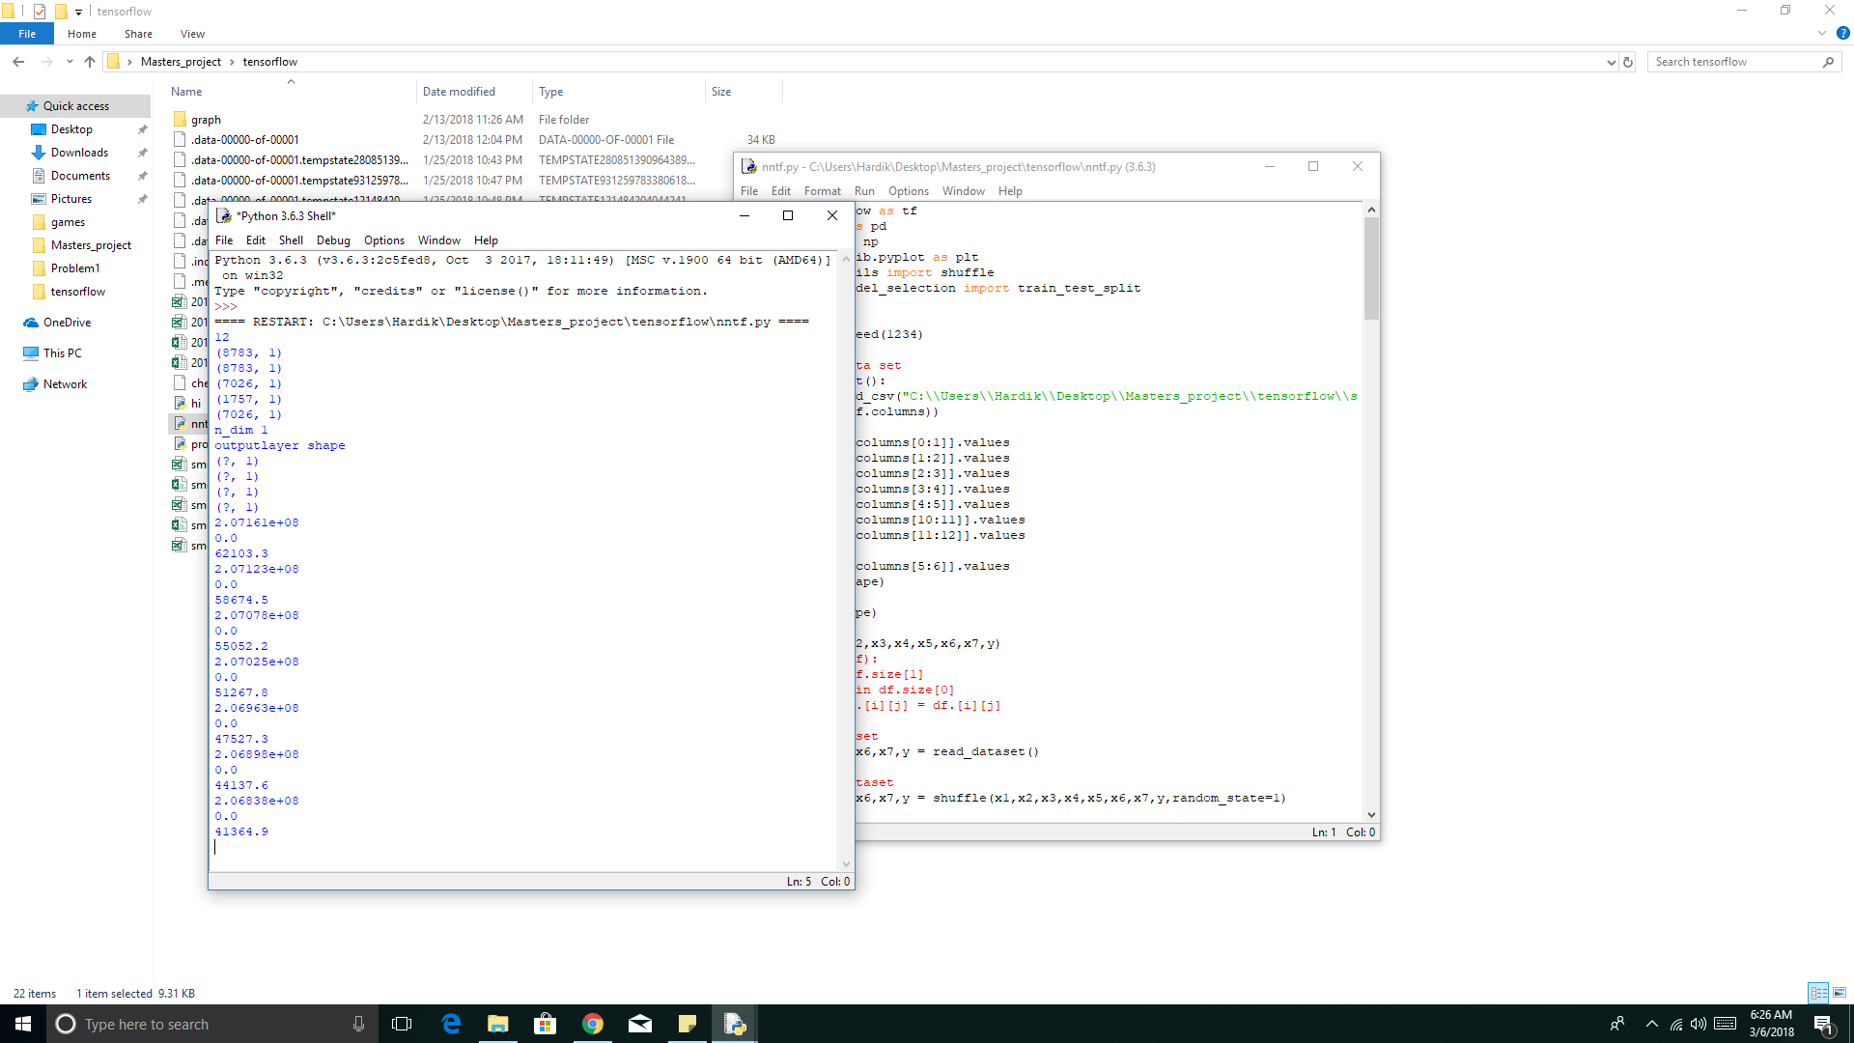

After the program has finished running, which may take from ½ hour to 10 hrs depending upon your system, we can see the computation graph (data flow graph) of out neural network.

To view the computation graph, go to tensorflow directory present in master’s project folder on cmd.

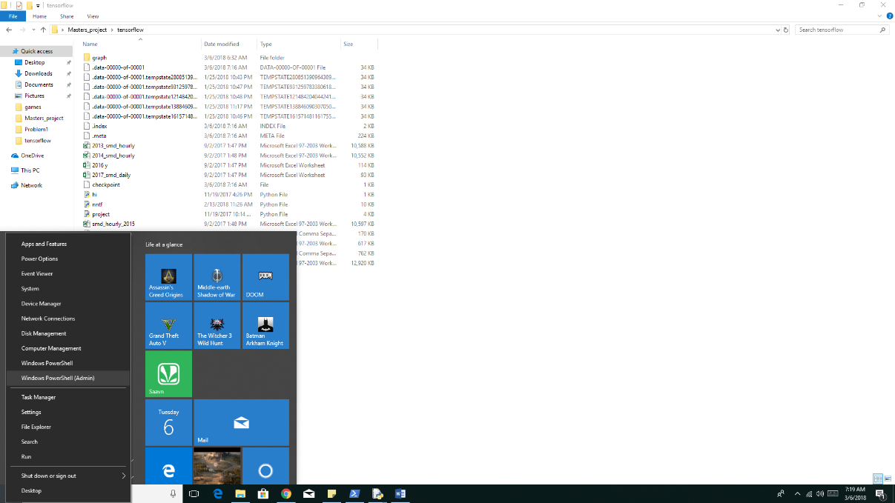

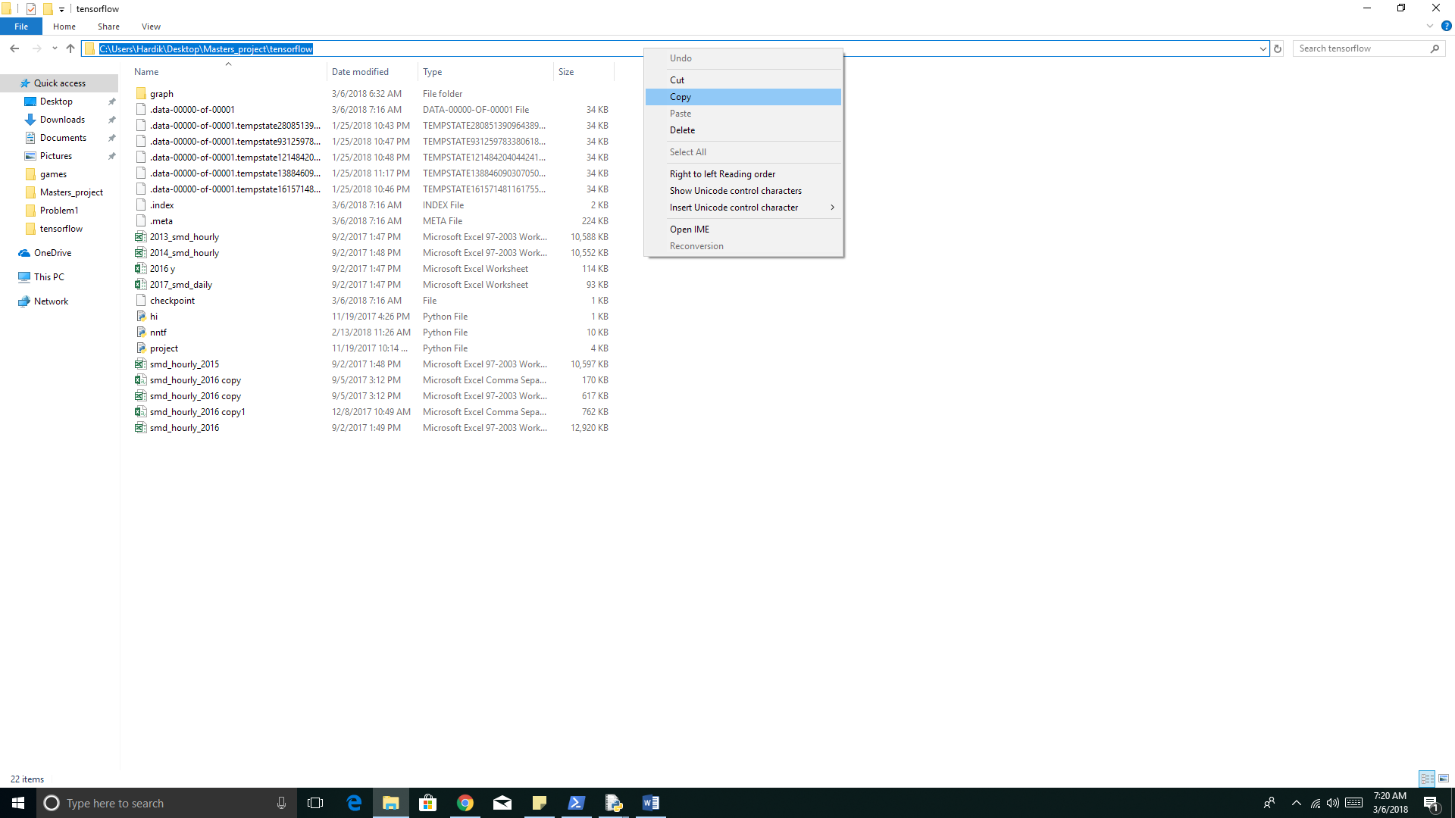

type in cmd the following

1.) tensorboard --logdir="graph"

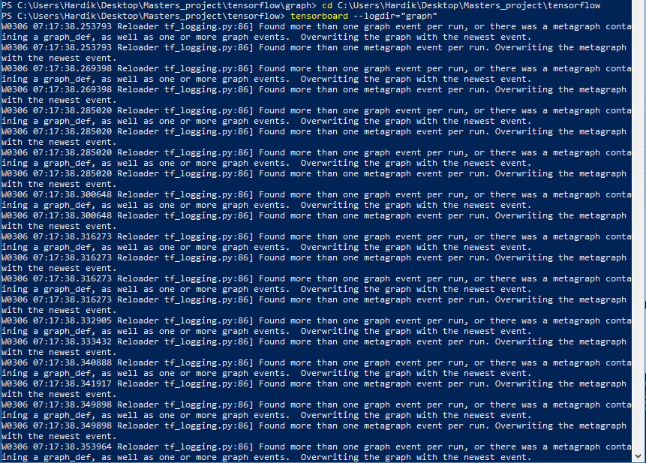

Open web browser (to see computation graph) and go to:-

<http://localhost:6006/>

